DICTIONARY PRACTICE

1. Write a Python script to sort (ascending and descending) a dictionary by value.

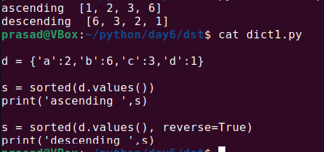

2. Write a Python script to add a key to a dictionary.

Sample Dictionary : {0: 10, 1: 20}

Expected Result : {0: 10, 1: 20, 2: 30}

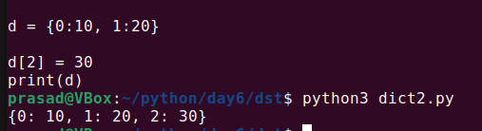

3. Write a Python script to concatenate the following dictionaries to create a new one.

Sample Dictionary :

dic1={1:10, 2:20}

dic2={3:30, 4:40}

dic3={5:50,6:60}

Expected Result : {1: 10, 2: 20, 3: 30, 4: 40, 5: 50, 6: 60}

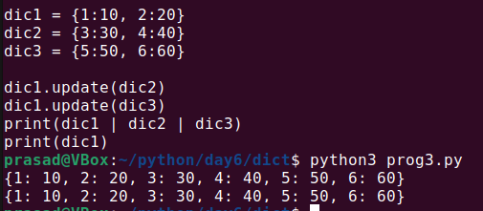

4. Write a Python script to check whether a given key already exists in a dictionary.

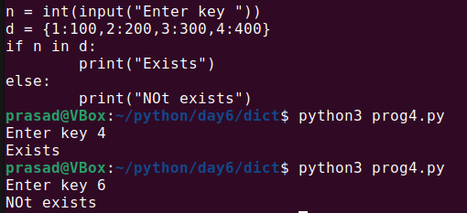

5. Write a Python program to iterate over dictionaries using for loops.

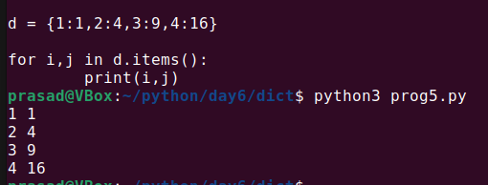

6. Write a Python script to generate and print a dictionary that contains a number (between 1 and n) in the form (x, x\*x).

Sample Dictionary ( n = 5) :

Expected Output : {1: 1, 2: 4, 3: 9, 4: 16, 5: 25}

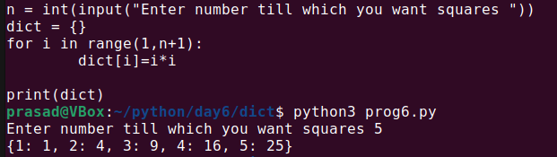

7. Write a Python script to print a dictionary where the keys are numbers between 1 and 15 (both included) and the values are the square of the keys.

Sample Dictionary

{1: 1, 2: 4, 3: 9, 4: 16, 5: 25, 6: 36, 7: 49, 8: 64, 9: 81, 10: 100, 11: 121, 12: 144, 13: 169, 14: 196, 15: 225}

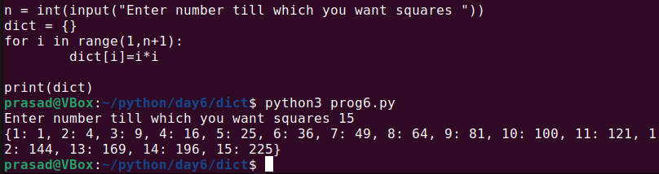

8. Write a Python script to merge two Python dictionaries.



9. Write a Python program to iterate over dictionaries using for loops.

10. Write a Python program to sum all the items in a dictionary.

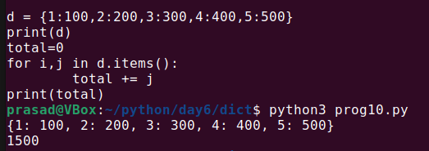

11. Write a Python program to multiply all the items in a dictionary.

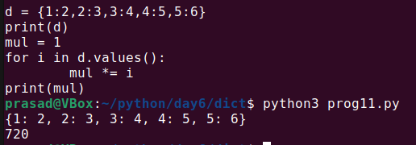

12. Write a Python program to remove a key from a dictionary.

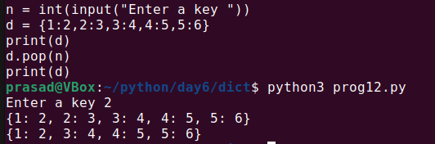

13. Write a Python program to map two lists into a dictionary.

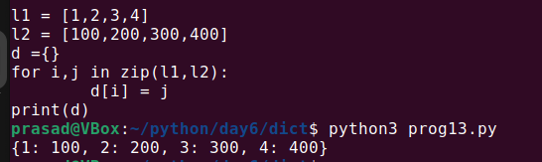

14. Write a Python program to sort a given dictionary by key. And output should be a dictionary.

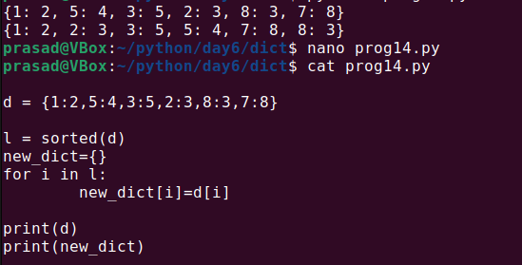

15. Write a Python program to get the maximum and minimum values of a dictionary.

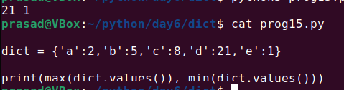

16. Write a Python program to get a dictionary from an object's fields.

17. Write a Python program to remove duplicates from the dictionary.

18. Write a Python program to check if a dictionary is empty or not.